Welcome to “The Arts”
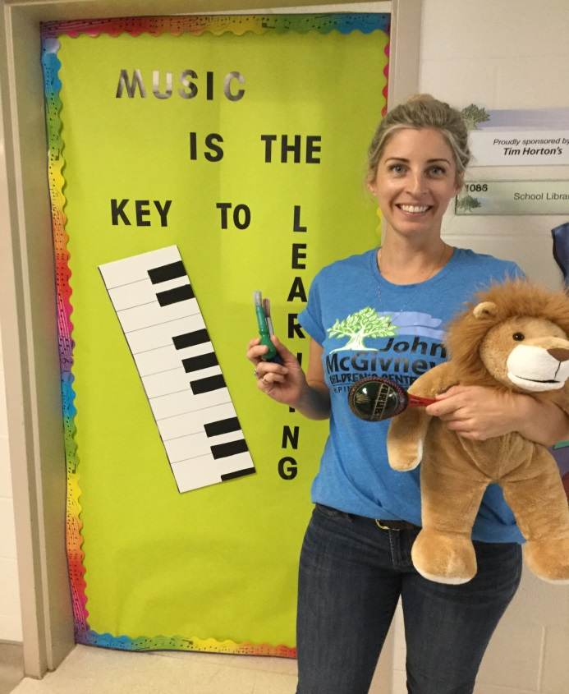
Welcome back to my returning students and a big hello to all of the new students and families. I am Mrs. Targachoff (the students know me as Mrs. T) and I will be teaching your children Art, Music and Drama this year.
Students will be provided the opportunity to listen, perform and explore music and music concepts. Students will be encouraged to get involved in the creative art process and learn proper terminology and some will build on concepts that they began last year.
We think sometimes play should be left to lunch time or the school yard, however in drama we play with scripts, props, costumes and even our minds. In drama we play a lot yes, this is okay, but from play stems some of our best material.
The arts promote the use of our own imagination, creates social skills, decision making, risk taking and motor skills. The arts have the ability to connect students with their own culture as well with the world.
I am eager and excited to be on this journey with your amazing children and look forward to meeting you.

Sincerely,
Mrs. Targachoff

